CANDLES

Price movements:

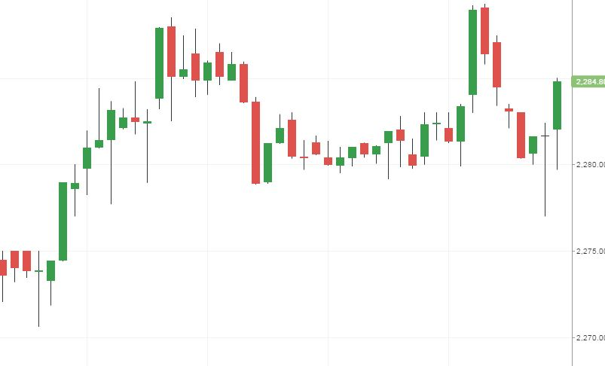

How to read?

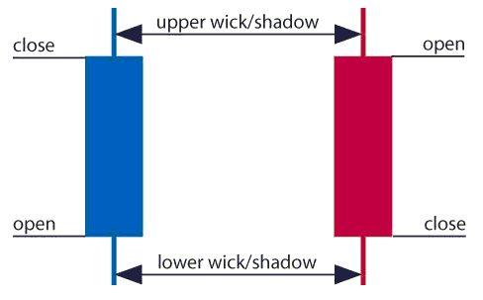

BID/ ASK

Price quotation that indicates the best price of currency of security.

Bid represents the maximum price that a buyer is willing to pay for currency.

Ask represents the minimum price that a [seller](https://www.investopedia.com/terms/s/seller.asp) is willing to receive.

Ask value > bid value (for the same asset)

WHO CAN SELL YOU AN ASSET?

Dealer- buys and sells themselves trying to have the highest profit.

Broker- organise a trade for clients and take a fee.

|  |  |  |  |
| --- | --- | --- | --- |
| ID | BUY | SELL | PROFIT/LOOSE |
| 1 | Date, time, price | Date, time, price | +/- |
|  |  |  |  |
| Total | - | - | sum |